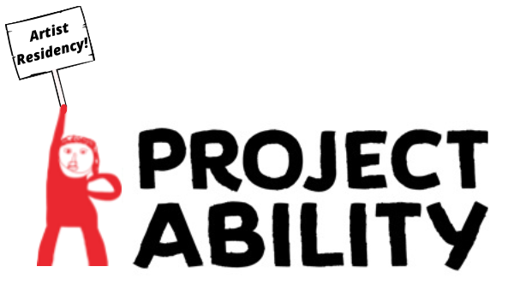

Artist in Residency Application Form

Please complete and return to Tracy Gorman at volunteers@project-ability.co.uk
Deadline 19th August 2022

Name

Address:

Postcode:

Telephone no: | Mobile no:
Email address:

Preferred Residency Dates: 5th -30th September / 3rd – 28th October

Social media handles:

Social media handles are not required but if you have an artistic practice or creative interests you’d like to share as a part of your application, please feel free to do so.

What Professional Qualifications do you have?

How did you find out about this opportunity?

What has interested you about this opportunity and what do you think you could gain from this experience?

Tell us a bit about your own practice? What artforms do you work with?

Additional information

Do you have any specific needs, e.g. access, medical conditions or disabilities you would like us to know about?
☐ No
☐ Yes (please give details)

Contact in case of emergency:

Please complete our equality, diversity and inclusion monitoring form included in our links
This will take no more than 1-2 minutes.

Declaration

I understand that my details will be kept securely. I understand that my personal details will only be used for the purpose of my Artist in Residency application, my possible subsequent Artists in Residents opportunity, and to keep me updated about any future Project Ability opportunities or events. I understand that my personal details will be kept in accordance with current data protection laws and best practice.

Signed____________________________ Date______________________________

Please return this form to:

Tracy Gorman Volunteers Co-ordinator
E. volunteers@project-ability.co.uk
T: 0141 552 2822

