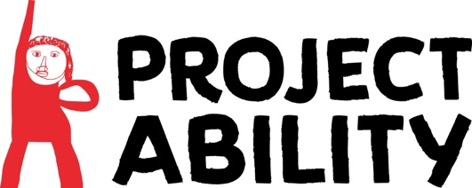

Equality and Diversity Monitoring Form – Volunteers and Artists in Resident

At Project Ability, we value diversity and are committed to creating a welcoming studio environment for all.

To enable us to do this in the best way we can, we continually monitor and reflect on or provision and practices, to ensure we meet the aims and objectives of our Equality Policy.

To help with this process, we very much rely on those taking part in opportunities with us, taking time to fill out this form. However, should you be uncomfortable in doing this, please know that it will not affect your application in any way as it is not a requirement.

If you are happy to support our monitoring and evaluation processes, please return the completed form to office@project-ability.co.uk or by post to Project Ability, 3rd Floor Trongate 103, Glasgow, G1 5HD

Gender
Man Woman Intersex Non-binary Prefer not to say
If you prefer to use your own term, please specify here …………………….

Age
16-24 25-29 30-34 35-39 40-44 45-49 50-54 55-59 60-64 65+ Prefer not to say

What is your ethnicity?
Ethnic origin is not about nationality, place of birth or citizenship. It is about the group to which you perceive you belong. Please tick the appropriate box

White
English Welsh Scottish Northern Irish Irish British Gypsy or Irish Traveller Prefer not to say
Any other white background, please write in here: …………………….

Mixed/multiple ethnic groups
White and Black Caribbean White and Black African White and Asian Prefer not to say
Any other mixed background, please write in here: …………………….

Asian/Asian British
Indian Pakistani Bangladeshi Chinese Prefer not to say
Any other Asian background, please write in here : …………………….

Black/ African/ Caribbean/ Black British
African Caribbean Prefer not to say
Any other Black/African/Caribbean background, please write in here: …………………….

Other ethnic group
Arab Prefer not to say
Any other ethnic group, please write in here: …………………….

Do you consider yourself to have a disability or health condition?
Yes No Prefer not to say

What is the effect or impact of your disability or health condition on your ability to give your best at work? Please write in here: …………………….

The information in this form is for monitoring purposes only. If you believe you need a ‘reasonable adjustment’, then please discuss this with your manager, or the manager running the recruitment process if you are a job applicant.

What is your sexual orientation?
Heterosexual Gay Lesbian Bisexual Prefer not to say

If you prefer to use your own term, please specify here ……………………………………………….….

What is your religion or belief?
No religion or belief Buddhist Christian Hindu Jewish
Muslim Sikh Prefer not to say

If other religion or belief, please write in here: …………………….

